# Final Exam 322

## Concepts question 3 complexity: Legal Responsibility

* **Diagram: no FSM, no petri**

**Will have state diagram (UML), col diagram**

**JSD tree (OOA), use case, E/R,**

* **Coupling & cohesion(high level)**
* **Design + coding + testing case design**

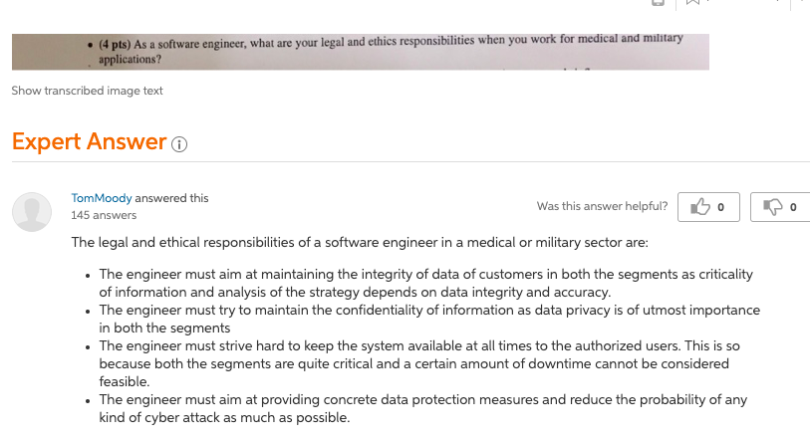

**Question2?**









**Question3?**



1. Download a digital picture; play a digital video: **Coincidental cohesion**

The Coincidental cohesion is the worst , when module grouped arbitrarily the relation is just they group together as in Download a digital picture; play a digital video tasks there are no relationship.

1. Parse the search criteria; search the DB for match: **Communicational/informational cohesion**

The Communicational cohesion module grouped task which operate on the same data. The Parse the search criteria; search the DB for match are using the same input or output data.

1. Locate the record to be update from DB; update the record; save the record back to the DB file: **Sequential cohesion**

The Sequential cohesion module grouped because output from task is the input to other task as sequence. The Locate the record to be update from DB; update the record; save the record back to the DB file perform in sequence so it is Sequential cohesion.

1. Design the system using OOD; implement the system using OOP: **Procedural cohesion**

The Procedural cohesion module group because certain sequence of steps has to be carried out to gain objective. As in Design the system using OOD; implement the system using OOP, the implementation step can perform after the design step so it is Procedural cohesion.

**Coupling:**

1. The coupling between module a and b is common coupling because they share the same global data.
2. The coupling between module a and c is content coupling because module c is occur in the module a.
3. The other coupling between module c and a is control coupling because the parameters passing by module a control the sequence of module c.



General program for K closest elements:

1) Start from the first element and search for the crossover point (The point before which elements are smaller than or equal to X and after which elements are greater). This step takes O(n) time.  
2) Once we find the crossover point, we can compare elements on both sides of crossover point to print k closest elements. This step takes O(k) time.

The time complexity of the above solution is O(n).

|  |
| --- |
| #include<stdio.h>  /* Function to find the cross over point (the point before     which elements are smaller than or equal to x and after     which greater than x)*/  int findCrossOver(int arr[], int low, int high, int x)  {    // Base cases    if (arr[high] <= x) // x is greater than all      return high;    if (arr[low] > x) // x is smaller than all      return low;    // Find the middle point    int mid = (low + high)/2; /* low + (high - low)/2 */    /* If x is same as middle element, then return mid */    if (arr[mid] <= x && arr[mid+1] > x)      return mid;    /* If x is greater than arr[mid], then either arr[mid + 1]      is ceiling of x or ceiling lies in arr[mid+1...high] */    if(arr[mid] < x)        return findCrossOver(arr, mid+1, high, x);    return findCrossOver(arr, low, mid - 1, x);  }  // This function prints k closest elements to x in arr[].  // n is the number of elements in arr[]  void printKclosest(int arr[], int x, int k, int n)  {      // Find the crossover point      int l = findCrossOver(arr, 0, n-1, x);      int r = l+1;   // Right index to search      int count = 0; // To keep track of count of elements already printed      // If x is present in arr[], then reduce left index      // Assumption: all elements in arr[] are distinct      if (arr[l] == x) l--;      // Compare elements on left and right of crossover      // point to find the k closest elements      while (l >= 0 && r < n && count < k)      {          if (x - arr[l] < arr[r] - x)              printf("%d ", arr[l--]);          else              printf("%d ", arr[r++]);          count++;      }      // If there are no more elements on right side, then      // print left elements      while (count < k && l >= 0)          printf("%d ", arr[l--]), count++;      // If there are no more elements on left side, then      // print right elements      while (count < k && r < n)          printf("%d ", arr[r++]), count++;  }  /* Driver program to check above functions */  int main()  {     int arr[] ={12, 16, 22, 30, 35, 39, 42,                 45, 48, 50, 53, 55, 56};     int n = sizeof(arr)/sizeof(arr[0]);     int x = 35, k = 4;     printKclosest(arr, x, 4, n);     return 0;  } |



**Answer:**

**code:**

Array = [1, 2, 3, 4, 6, 7, 8, 9, 0]

voosh = int(input("Enter query: "))

# the list to maintain the difference with each element along with index of that element

diffrences = []

for i in range(len(Array)): # first loop

diffrences.append((abs(Array[i] - voosh), i))

diffrences = sorted(diffrences) # Sorting the list of diffrences

# top 5 difference elements are accessed here

for tup in diffrences[:5]: # second loop

print(Array[tup[1]]) # Accessing index of current tuple and printing the number at that index from Array

**Output:**

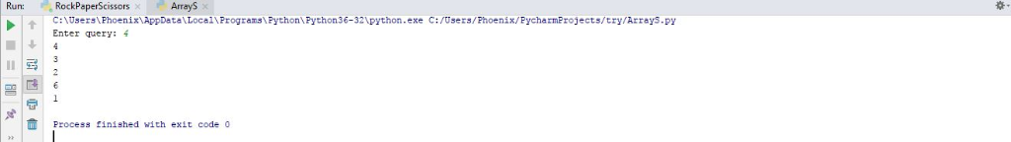

**Time Complexity:**

**First loop: O(n)**

**Inbuilt sorting: O(n log n)**

**Second loop: O(5)**

Complexity = n + n log n + 5 = **O( n log n)**



here is your Answer : -------------------->>>>>>>>>>>>>>

void mingle2Array(int A[],int B[],int n1,int n2){  
int *c = new int[n1+n2];  
int nc1 = 0,nc2 = 0;  
for(int i = 0;i<n1+n2;i++){  
  if(i%2 == 0){  
   c[i] = A[nc1];  
   nc1++;  
  }  
  else{  
   c[i] = B[nc2];  
   nc2++;  
  }  
}  
}

I will write 3 black box test cases for this requirement as :  
1. all values equals    input = A[2,2,2,2,2,2,2,2,2] , B[4,4,4,4,4,4,4,4,4]   output = C[2,4,2,4,2,4,2,4,2,4,2,4,2,4,2,4,2,4]  
2. size vary          input = A[1,5,7,8] , B[2,9]      output = C[1,2,5,9,7,8]  
3. ascending order     input = A[1,3,5,7,9] B[2,4,6,8,10]   output = C[1,2,3,4,5,6,7,8,9,10]



//MergeSortedArrays.java

**import java.util.Arrays**;

**public class MergeSortedArrays** {

**public static int**[] merge(**int** arr1[], **int** arr2[]){

**int** len1 = arr1.length,len2 = arr2.length;

**int** i = 0,j = 0,k = 0;

**int** arr[] = **new int**[len1+len2];

**while**(i<len1 && j<len2){

**if**(arr1[i] <= arr2[j]){

arr[k++] = arr1[i++];

}

**else** {

arr[k++] = arr2[j++];

}

}

**while** (i<len1){

arr[k++] = arr1[i++];

}

**while** (j<len2){

arr[k++] = arr2[j++];

}

**return** arr;

}

**public static void** main(**String** args[]){

**int** list1[] = {1, 4, 10};

**Arrays**.sort(list1);

**System**.out.println("A: " + **Arrays**.toString(list1));

**int** list2[] = {2, 3, 11};

**Arrays**.sort(list2);

**System**.out.println("B: " + **Arrays**.toString(list2));

**int** result[] = merge(list1, list2);

**System**.out.println("C: " + **Arrays**.toString(result));

}

}

